

FACULTY
OF
INFORMATION
AND
COMMUNICATION TECHNOLOGY

DEPARTMENT OF INFORMATION TECHNOLOGY

PROJECT PROPOSAL

COURSE: [Communication Networks]
SUBJECT CODE: IDC30BC
PROJECT NAME: (High Availability Network Upgrade for WireSpeed Systems)
SUBMISSION DATE: 10th of September 2021
PROJECT CO-ORDINATOR: MR. Z. Mapundu

STUDENT DETAILS:

SURNAME & INITIALS: Monyela ML

STUDENT NUMBER: 216771877

EMAIL ADDRESS: lodrickmonyela98@gmail.com

CONTACT NUMBERS: 0782535251

TABLE OF CONTENTS

1. Project Name 3
2. Team Members 3
Background & Current Practices/Problems 3
3. Project Description 3
4. Project Components and Technologies 4
5. Project Plan & Network Diagram 4
6. Budget Plan 7
7. Conclusion 8
8. References 8

- Project Name
High Availability Network Upgrade for WireSpeed Systems
- Team Members
Project duties for: Lodrick
• Evaluation and analyzing of the network.
• Designing of the network infrastructure.
• Configuration of Equipment.
• Configuration of IPsec and port security.
• Testing of the entire network and fixing errors.

Background & Current Practices/Problems
Wire Speed Systems provides a Professional IT management and support service specifically aimed at small to medium-sized enterprises. We offer affordable IT management & Training solutions that are tailored around our customer’s individual IT requirements. At Wire Speed Systems, we are committed to service delivery excellence and our customers who span a variety of industries and vary in size.

Below is the outlined network issues identified within WireSpeed Systems network infrastructure.
- Their network is currently not well segmented – meaning that certain users have unauthorized access to services, no layered mannered architect, the computers are randomly connected to the access switches, this has made cabling complex.
- They deployed a single core layer 3 switches.
- Servers are connected to the switch with a single cable.
- No DR site- they perform manual-backups by using disk hardrive, this post a risk as it can be stolen.
- Low bandwidth due to large number of enrolled learners connecting to the internet during classroom hours.
- No network redundancy, causing single point of failure.
- The network is not reliable and scalable, and it does not handle the high demand due to number of staff and learners being employed in the organization.
- The company is using legacy systems that cannot handle future expansion or upgrade.
- Project Description
The purpose of this project is to improve the network performance for WireSpeed Systems. I’m going to configure IPsec and SSH on routers to improve network security and separate the departments by creating VLAN for privacy. Then to implement site-to-site, IPSEC VPN, and ACL to strengthen our security. Implementation of HSRP (load balance) to improve the network performance. Implement link and hardware redundancy in order to have reliable network by eliminating single point of failure. Further implementing data recovery site for backup of information. I’m also going to implement Frame Relay to interconnect the two branches.

- Project Components and Technologies

Technologies:
- VOIP
- VLAN
- VTP
- Frame-relay
- DNS
- Rapid STP
- Dynamic Routing protocol
- DHCP server
- VPN Ipsec
- ACLs- software based Firewalls.
- Port security.
- EIGRP
- SMTP, IMAP, POP3
- SSH
- EtherChannel-Link -Link aggregation.

Components:
Router - 2811 cisco router, a router is a device that forwards data packets along networks and is located at gateways, the places where two or more networks connect, and are the critical device that keeps data flowing between networks and keeps the networks connected to the Internet.

Firewall - A Firewall is a single choke point that keeps unauthorized users out of the protected network, prohibits potentially vulnerable services from entering or leaving the network, and provides protection from various kinds of IP spoofing and routing attacks.
Switch - Cisco Catalyst 2960 Series Switches layer 2, a switch is a device that is used at the Access or OSI Layer. A switch can be used to connect multiple hosts (PCs) to the network. A switch sends a message to another host on the same network or same switch, the switch receives and decodes the frames to read the physical (MAC) address portion of the message.
Cables, Is used to connect one network device to other network devices or to connect two or more computers to share printer, PCs etc. category 6 cabling have fewer errors for current applications. This means fewer re-transmissions of lost or corrupted data packets under certain conditions, which translates into higher reliability for category 6 networks compared to category 5e networks.
DHCP server - DHCP servers centrally manage IP addresses and related information and provide it to clients automatically.
Database server - is a computer in a LAN that is dedicated to database storage and retrieval of data.
DNS (Domain Name System) - is the service used to convert human readable names of hosts to IP addresses
VPN (virtual private network) – is a network that uses a public telecommunication infrastructure, such as the Internet, to provide remote offices or individual users with secure access to their organization's network.

Patch panel - Patch panels’ offer the convenience of allowing technicians to quickly change the path of select signals, without the expense of dedicated switching equipment. Is a panel that contains multiple cable connections, the back of the panel has wiring or other connective cabling that runs to disparate equipment. The front of the patch panel allows easy access to connect the different equipment through the use of short patch cables.

IDPS - is used to detect and prevent who try to access our data on the network or any information that is not belonging to the network by telling the administrator with a notification.

Dell PC - Consists of two or more computing devices connected by a medium allowing the exchange of electronic information.
- Project Plan & Network Diagram
IP ADDRESS SCHEME
MAIN BRANCH- RANDBURG
Subnet: 172.16.0.0/16

Name | Hosts Needed | Hosts Available | Unused Hosts | Network Address | Slash | Mask | Usable Range | Broadcast | Wildcard
VOIP SERVICE VLAN 100 | 1000 | 1022 | 22 | 172.16.0.0 | /22 | 255.255.252.0 | 172.16.0.1 - 172.16.3.254 | 172.16.3.255 | 0.0.3.255
Internship/Learnership VLAN 200 | 400 | 510 | 110 | 172.16.4.0 | /23 | 255.255.254.0 | 172.16.4.1 - 172.16.5.254 | 172.16.5.255 | 0.0.1.255
IT DEPARTMENT  VLAN 300 | 250 | 254 | 4 | 172.16.6.0 | /24 | 255.255.255.0 | 172.16.6.1 - 172.16.6.254 | 172.16.6.255 | 0.0.0.255
RECRUITMENT  VLAN 400 | 200 | 254 | 54 | 172.16.7.0 | /24 | 255.255.255.0 | 172.16.7.1 - 172.16.7.254 | 172.16.7.255 | 0.0.0.255
SERVER-ROOM  VLAN 500 | 100 | 126 | 26 | 172.16.8.0 | /25 | 255.255.255.128 | 172.16.8.1 - 172.16.8.126 | 172.16.8.127 | 0.0.0.127
LAN ROUTERS | 2 | 2 | 2 | 172.16.8.128 | /30 | 255.255.255.252 | 172.16.8.129-172.16.8.130 | 172.16.8.131 | 0.0.0.3

DISASTER RECOVERY SITE
Name | Hosts Needed | Hosts Available | Unused Hosts | Network Address | Slash | Mask | Usable Range | Broadcast | Wildcard
DC IT ADMINISTRATORS VLAN 300 | 150 | 254 | 104 | 172.16.9.0 | /24 | 255.255.255.0 | 172.16.0.9 - 172.16.0.254 | 172.16.9.255 | 0.0.0.255
SERVER-ROOM VLAN 500 | 100 | 126 | 26 | 172.16.10.0 | /25 | 255.255.255.128 | 172.16.10.1- 172.16.10.126 | 172.16.10.127 | 0.0.0.127
LAN ROUTERS | 2 | 2 | 0 | 172.16.10.28 | /30 | 255.255.255.252 | 172.16.10.29-172.16.10.30 | 172.16.10.31 | 0.0.0.3

Project Plan
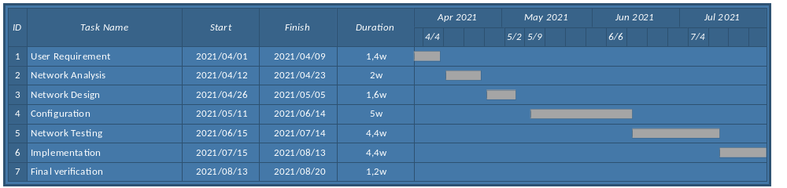
PROBLAMETIC DIAGRAM
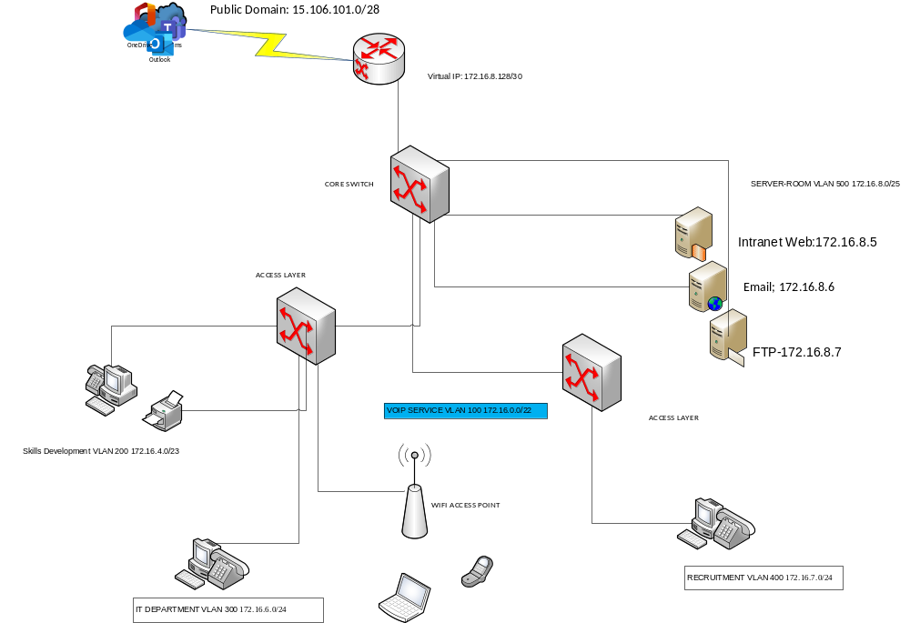

PROPOSED DIAGRAM
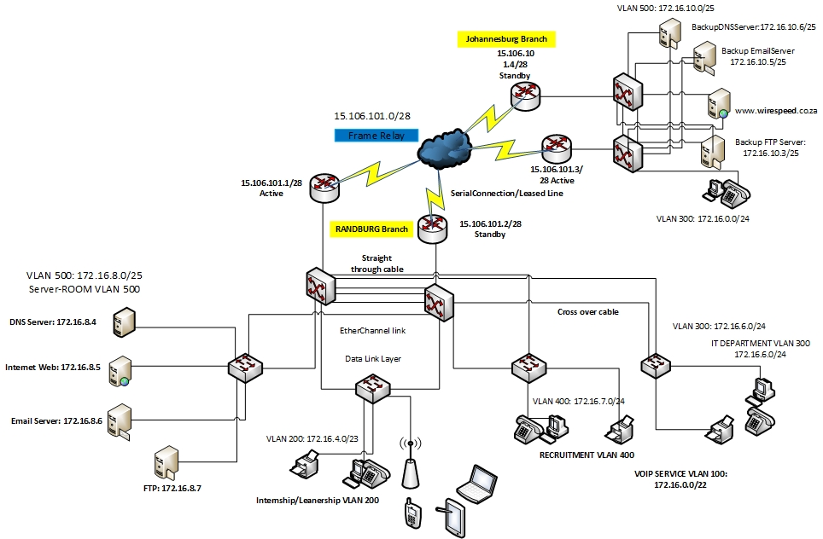

- Budget Plan
Device | cost | quantity | total
2960 Switches | R12 499.00 | 10 | R124 999
2811 Routers | R23 905,00 | 6 | R143 430
VOIP phones | R1500 | 50 | R7500
Server | R18 330,00 | 10 | R183 330
- Conclusion
I believe that when I implement the new network diagram all problems identified will be solved, Praise IT Solutions will be more secured, not everyone will have access to confidential information, and the network will be available, reliable and scalable all the times. I will be in a jubilant mood if my project becomes successful.
- References
Network-security-essentials-4th-edition-william-stallingsNetwork_Security_Essentials-byWilliam_Stallings_[DroidD]
Guide to Network Defense and Countermeasures Third Edition
www.cisco.com/security
ccna security

FORMAT

HEADINGS: Arial, 24
BODY: Arial, 12,
SPACING: 1.15

